PRACTICAL-3

Code: ipconfig

Ping 8.8.8.8

netstat

tracert www.google.com

ipconfig

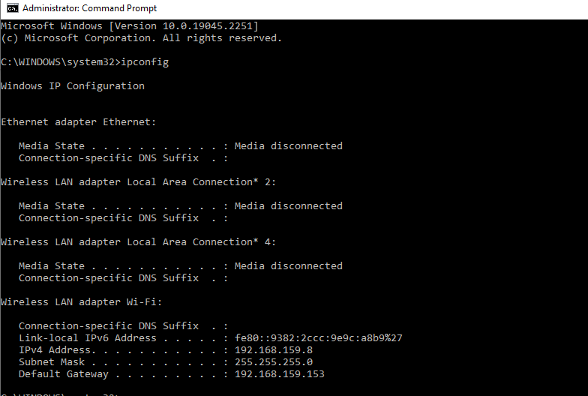

Ping

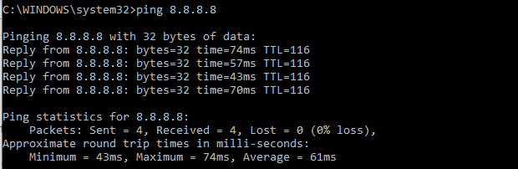

Netstat

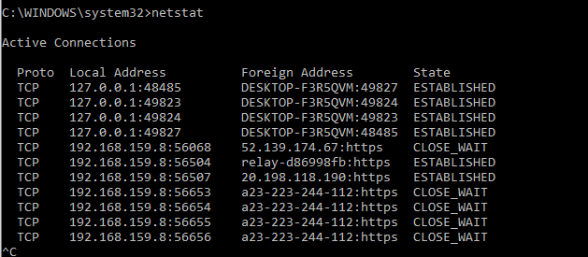

Traceroute Tracert command

